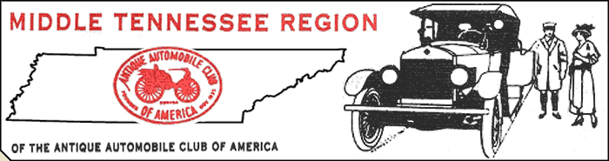
Glenn Edwards, President ~ Dr. Roger McKinney, Vice-President ~ Read Majors, Secretary ~ Marc Humes, Treasurer

January 2010

My Friends,

Mid-Tenn in 2010! We've hit the ground runnin'. Our usual events are scheduled (you may want to save the Events 2010 page on your memo board or refrigerator for reference) plus some new stuff! We had 30 members show up for the Jan. meeting, but we need to have everybody in attendance. This is your club and your participation is vital to our success! Planning has already begun for the Red Boiling Springs Show which is our premier annual event. It takes 'All Hands on Deck' to do any of our shows properly, but the sheer size of RBS requires extra manpower.
As many of you know the possible closing of the Nashville Fairgrounds has left the annual Stones River Swap Meet in limbo. Regardless of the uncertain situation in Metro a proposal was made and approved (Jan. meeting) to have the board explore the feasibility of MTRAACA hosting such an event next year. On Thursday Jan 21 the board met and came up with this plan. We have put a hold on the Wilson County Fairgrounds for a weekend in late Feb. and have drawn up floor plans to see what spaces both heated and open might be available. Our next move is to contact the current vendors at the swap meet on Feb. 7th and get as many commitments $$$ from them for next year as possible. We need help on that day to hand our flyers, give info and assist with the sign up. We will meet at @6:30 AM at the swap meet entrance. It's a fun get- together and you can still shop for your car-parts while you support the club.

- Pot-Luck Supper – Friday Feb. 12th at 6:30 PM at the “Clubhouse in the Grove.”
- David “Weegie” Weigant is out of the hospital and resting at home. Thoughts and prayers, David.

EXCERPT FROM LAST NEWSLETTER – TAKE HEED!

Local and AACA National membership dues are payable immediately. AACA National = $35.00 and our Region dues are: $10.00 for a single membership and $15.00 for member and spouse. Some folks pay their National dues directly to Hershey, but it may be easier to just send a check (made out to Mid-TN Region AACA) for a total of either $45.00 or $50.00 depending on your situation and we'll take care of the rest. Your AACA card will be sent directly to you from Hershey and your Mid-TN card will be available at our meetings or can be mailed. Please take care of this soon so you'll be “official” and Marc and I can move on to other duties. Send your payment today to:
Read Majors
118 Countrywood Drive
Lebanon, TN 37087
One last piece of business. If you have an e-mail address send it to me: Goshoot@Bellsouth.net
and I will send you an e-copy of all correspondence. Also if you give specific permission I will send you only an electronic copy and save the club the postage involved in mailing newsletters,etc. When you send your e-mail address just let me know if that option suits you. Obviously if you don't have e-mail, nothing changes, you will receive your newsletters via U.S. snail mail. Feel free to e-mail or call me for any questions you may have (615-483-2661.)

Next meeting February 14, 2010 - 2 PM at the “Clubhouse in the Grove.” Be there!
RM

